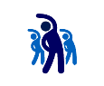Exercise #5 – Website building: Responsiveness

The following exercise contains the following subjects:

* HTML
* CSS

# Question

Create a stripe with a background image and add some text above it. Align the text to be vertically aligned exactly in the middle of the image. Try using the different methods that we saw in the presentation.



